V. Skvortsov
ICS8-22
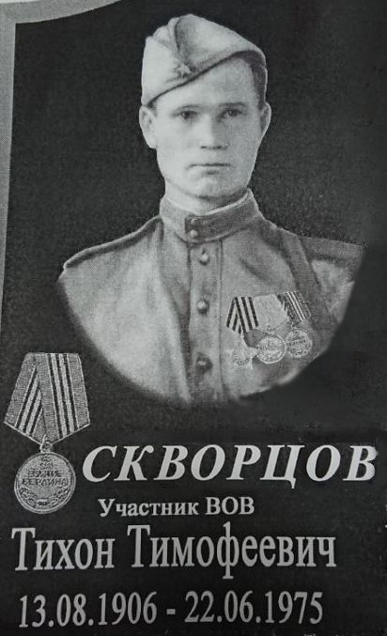
This year marks the 75th anniversary of the victory of the Soviet troops over the fascist invaders. The Great Patriotic War crept up to us imperceptibly, we were not ready for the immediate start of hostilities. However, this did not prevent us from building up strength during the war and repelling the enemy. Unfortunately, this war was the bloodiest in the history of our country. Millions of soldiers were killed in fierce battles, became disabled or completely disappeared. But such was the price of victory over the ruthless German military machine, which destroyed everything in its path. Soviet soldiers fought fearlessly, overcoming pain and loss. Their main task was to save the Motherland. And we must understand that besides heroes, everyone who survived this bitter period of time and did not betray is worth respect, since all of them contributed to the victory.
Skvortsov Tikhon Timofeevich
In this text, I would like to tell you about my great-grandfather Tikhon Timofeevich Skvortsov, but, unfortunately, there is still little information about him. However, I know that he was born in the Tambov region in the village of Sredny Pupki in 1906 in the village of Shedrye Pupki, which was renamed Oktyabrskaya after the revolution. Oktyabrskoe is a village in the Sosnovsky district of the Tambov region, a rural settlement located on the left bank of the small river Chicherka, a tributary of the Chelnova. It was founded as the village of Srednye Pupki in 1639, together with the neighboring villages of Upper Pupki and Nizhny Pupki. From the very beginning it was a very important military point. It was located on a “guard stitch” along which a horse patrol passed, observing the emergence of the Tatar troops. The word pupki means navels or heights in Russian. Here is what was written about it in a scribe book compiled by Prince D. Nesvitsky in 1650-1652: “The village of Sredny Pupki on the river of Chelnova is for the boyar children in the estate, that was formerly the village belonging to the centurion, to Peter Figlev and that "Peter's estate for theft was given to the children of the boyars." After listing all the householders and their land allotments, the final entry reads: “And in total in the village ... seven yards, and 21 places are the yard of landowners, and there are 102 people in them ...” Prior to going to the army in 1944, Tikhon Timofeevich worked as a machine operator on a collective farm. He reached Berlin and ended the war with the rank of the Red Army guard soldier. After the war, he continued to work on the collective farm. For military merits, he received several awards: the medal "For Military Merit", the Order of Glory, III degree, the medal "For Victory over Germany in the Great Patriotic War of 1941-1945."
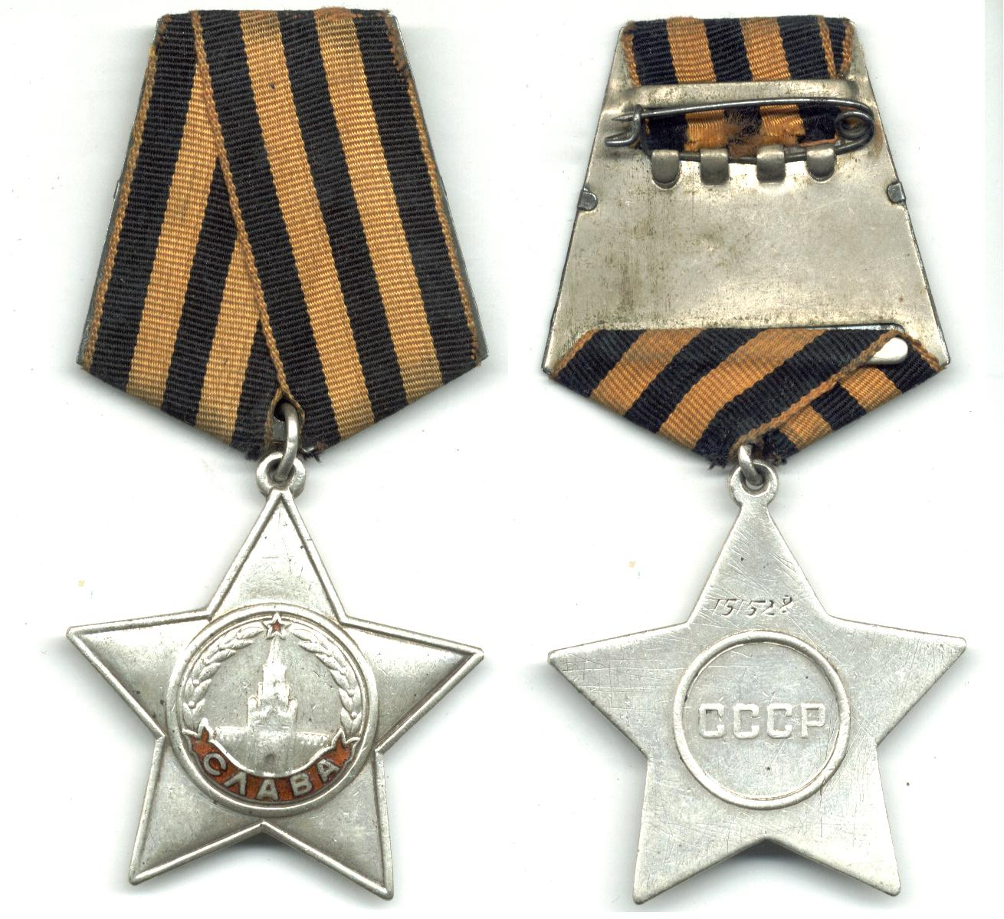
I am take a pride in my great-grandfather’s awards especially in his Order of Glory. It was established by Decree of the Presidium of the Supreme Soviet on November 8, 1943. It was awarded to privates and sergeants of the Red Army as well as to aviation junior lieutenants, for bravery in the face of the enemy. This Order of Glory has three degrees: I, II and III degrees. The highest degree of the order is I degree. The Order of Glory was modelled closely after the Tsarist Cross of St. George. Like the Cross of St. George, a soldier would initially be recommended for the order's lowest class - its third class. Originally, the Order of the Soldiers was supposed to be named after Bagration. A group of nine artists developed 26 sketches. 4 of them were selected and presented to Stalin on October 2, 1943. It was envisaged that the order would have four degrees and be worn on a black and yellow ribbon - the colors of smoke and flame. N.I. Moskalev proposed the St. George ribbon. Stalin approved it and decided that the order would have three degrees, as well as the orders of Suvorov and Kutuzov. Having said that victory cannot be without glory, he proposed to name the award the Order of Glory.
Medal of Glory III degrees
Although I do not have much information about my great-grandfather, his merits rouse some glory in my sole.
The date of his death is also very symbolic for a participant in the Great Patriotic War. He died exactly 34 years after his outbreak - June 22, 1975.

Bibliography:
Skvortsov Tikhon Timofeevich:
https://pamyat-naroda.ru/heroes/podvig-chelovek_kartoteka1007294857/
Srednye Pupki:
https://tambovgrad.ru/Tambovskaya-oblast/369-Oktjabrskoe-selo.html

